Intelligent Systems
Rule Based System – Freshwater Invertebrate Identification
Caine Morris – 30018722



Table of Contents
Introduction 3
System Design and Logic 3
Possible Improvements Error! Bookmark not defined.
Human Factors 6
Wider AI Context 7
Conclusion 7

Table of Figures

Introduction
“Expert Systems are systems which are capable of offering solutions to specific problems in a given domain or which are able to give advice, both in a way and at a level comparable to that of experts in the field.” (Lucas and Van, 1991).
This report presents the design, implementation, and evaluation of an expert system developed using the CLIPS (C Language Integrated Production System) language. It also places the system within the wider context of artificial intelligence, addressing the ethical, commercial, and social considerations associated with such technologies.
The expert system described in this report is designed to assist in identifying freshwater invertebrates. It aims to replicate the reasoning process of an expert biologist by guiding users through a structured, question-based decision process based on observable characteristics.

System Design and Logic
  - An Overview of Expert System Architecture and CLIPS
Expert System architecture typically consists of three main components: the knowledge base, the working memory, and the inference engine. The knowledge base stores the domain-specific knowledge in the form of facts and rules, which the system uses to arrive at an outcome or recommendation. Facts describes the currently known information, and rules represent expert knowledge in the form of IF-THEN. Together, these simulate the way an expert may come to decision, an example of this logic path may look like “IF this fact is true, THEN this is the next step.”
The working memory holds the set of facts that are active in the system and allows them to be actively modified as the program runs and a conclusion draws near.
Lastly, the inference engine is the component of the system that is responsible for comparing the facts with the rule set, and deciding which rules should be fired, for example, if there is a fact in the working memory that says “colour = blue”, the inference engine would look through all the rules to find if any of them have a condition that says “IF colour = blue”, and if a rule was found, it would launch that rule accordingly.
Expert systems can use either forward chaining or backward chaining as their reasoning strategy. Forward chaining is the process of applying rules to the available data to get new information, until a conclusion is reached. Whereas backward chaining begins with a potential goal and works backwards to see which facts would support the goal.
To implement the reasoning process for this project, CLIPS was chosen as it provides an efficient forward chaining inference engine, and its syntax and reasoning model are particularly well suited for diagnostic and classification systems such as this one.
  - Invertebrate Identification Expert System Design
The design of the invertebrate identification system was based on this provided decision tree that outlined the logical flow of the identification process.
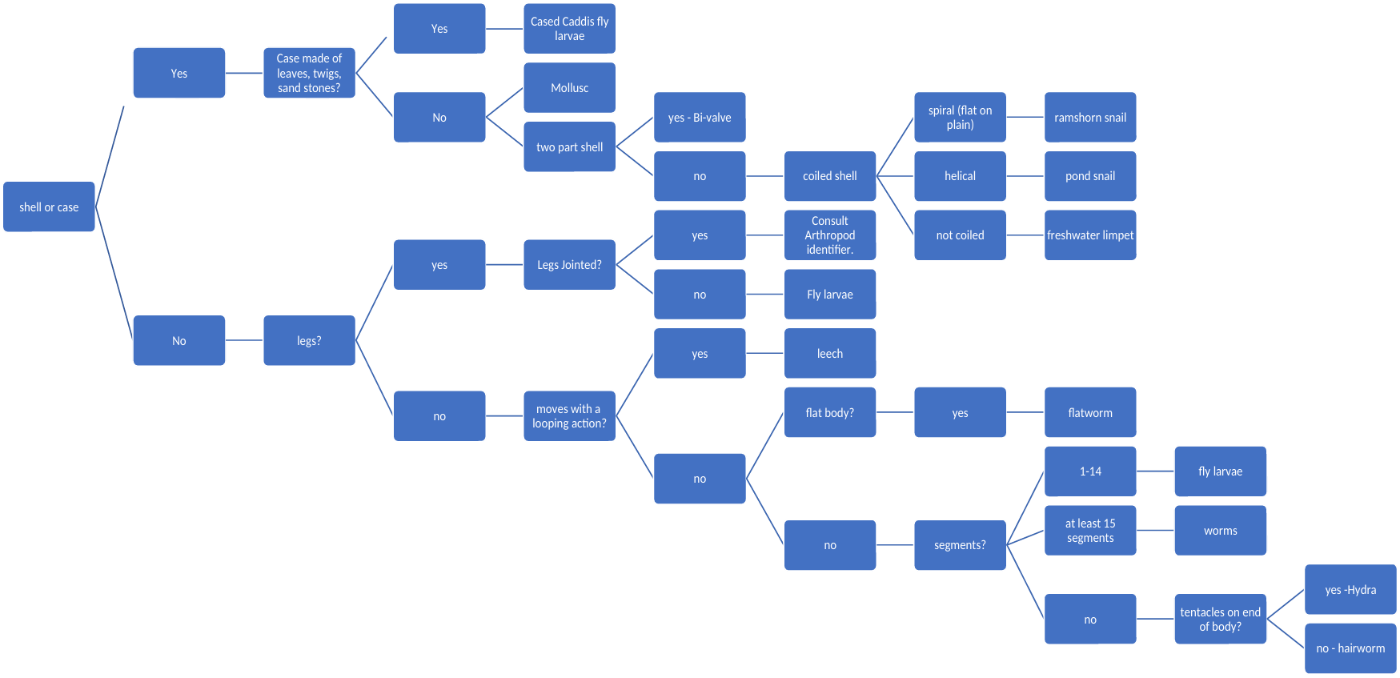
Figure 1 - Invertebrate Identification Decision Tree
The decision tree provided operates within specific constraints, being applicable to only to freshwater invertebrates larger than 2 millimetres in length and excluding species adapted to movement on the water’s surface, such as skating or surface-dwelling organisms. To account for these constraints, the programs beings with two prerequisites questions designed to ensure that only suitable specimens proceed to identification. The first asks, “Is the invertebrate 2mm or longer?”, while the second asks, “Does the invertebrate live on the water surface, or skate on the water surface?”. If the user responds “no” to the first question or “yes” to the second, the program notifies them that the specimen cannot be reliably identified using this system, as demonstrated in the following images.
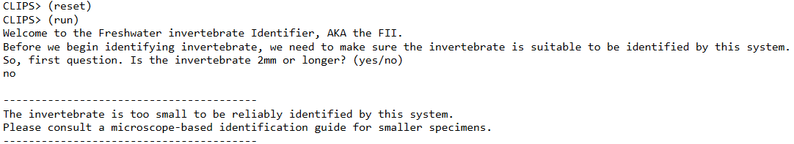
Figure 2 - A consultation where the specimen is less than 2mm long.
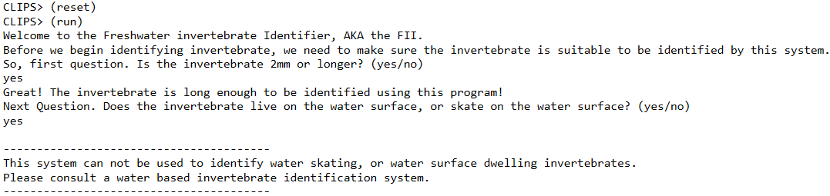
Figure 3 - A consultation where the specimen lives on the water surface, or skates on the water surface.
Once the prerequisite checks have ensured that the specimen is suitable to follow the given decision tree, the program that transitions into the main classification process. This process is structured around a fact-based control mechanism using the flowchart-step fact, which determines which question of the decision tree the user is currently on. The flowchart-step fact contains a slot named question-to-ask, which is modified at the end of each question, depending on what the user answers. For example, using the decision tree above as a guide, the question-to-ask slot gets set to the shell or case question once the user passes the prerequisites. If the user answers yes to the question, the question-to-ask fact is modified to be the case material question, and if the user answers no, the question-to-ask fact is modified to be the legs question.
Figure 4 - Program output demonstrating the output of a "yes" answer.
Figure 5 - Program output demonstrating the output of a "no" answer.
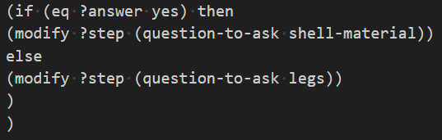
Figure 6 - A code snippet showing the question-to-ask being modified depending on the answer.
After each question, a new fact is asserted containing both the question asked and the user’s response. These facts are later retrieved at the end of the program, once the specimen has been identified, to display the reasoning path the system followed to reach its conclusion. When sufficient information has been gathered to make an identification, a final fact is asserted containing the specimen’s name. The inference engine then detects the presence of this identification fact, triggering the report-identification rule, which outputs the determined species along with the full sequence of questions and answers that led to the result.
Figure 7 - A code snippet showing the question and answer being asserted.
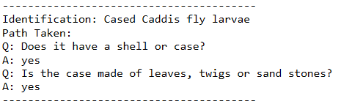
Figure 8 - The program output showing the specimen identification and the path taken.
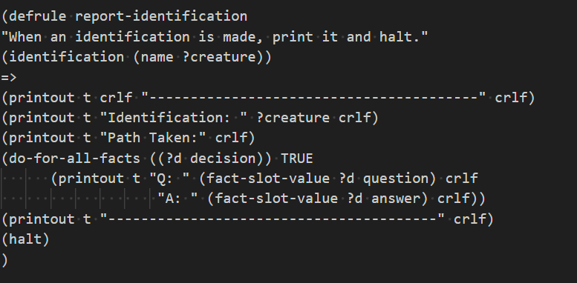
Figure 9 - A code snippet showing the report-identification rule.

Human Factors
During the development of the expert system, consideration was given to the fact that the end user would be human, and likely to have limited experience in invertebrate identification. Consequently, several features were implemented to support usability and minimise the potential for user error.
Input validation was implemented to ensure that the user cannot make a mistake when answering a question, and in the case, they do, is prompted to answer again. To make sure the user knows what answers the system wants, they are placed at the end of the question (for example “yes / no”). To make the system even more failure proof however, the system also accepts answers that are missing hyphens and are in a different case than expected.
Contextual examples were added to the end of questions to assist users in understanding each question. By providing examples such as “Does the shell have two parts (like a clam)?”, the system helps clarify potentially ambiguous terminology and helps support users who are unfamiliar with biological classification.
Informative feedback messages are displayed throughout the program to help guide the user’s experience. For example, if the specimen does not meet the prerequisites for identification, the system explains why the process cannot continue, and offers appropriate guidance, ensuring that the users are left with an idea of where to go next, instead of leaving them at a dead end.

Wider AI Context

Conclusion

